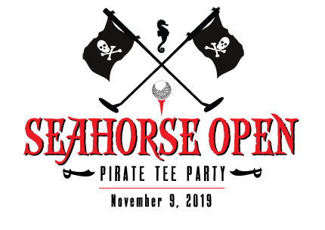
MYSTIC KREWE OF THE SEAHORSE
998A Highway 90 ٠ Bay St. Louis, MS 39520
228-216-6416 ٠ mkotshtreasurer@gmail.com ٠www.mkotsh.com
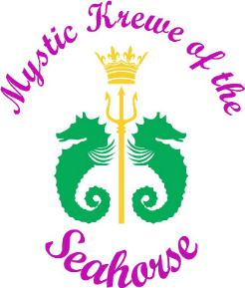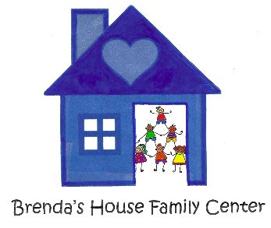
SEAHORSE OPEN HOLE SPONSORSHIP APPLICATION

Saturday, November 9, 2019 ٠ 4:00 p.m. – 8:00 p.m.

Please provide the following information and return this form with payment to
MKOTSH ٠998 A Highway 90٠ Bay St. Louis, MS 39520 or contact Ginny Cabell at 601-953-1972 for pick up.

BUSINESS NAME: ___________________________________________________________

CONTACT NAME: ___________________________________________________________

BUSINESS ADDRESS: ________________________________________________________
CITY: ______________________________STATE: ________________ ZIP: _____________
EMAIL ADDRESS: ____________________________________________________________
CELL PHONE:____________________________ BUSINESS PHONE: __________________
Please Check One:
Sponsoring Business provides its own Putt Putt Hole ____________ $30
Sponsor Rents the Hole from the Krewe ____________ $40
Extra Donation to Brenda’s House Family Center $____________________________
Amount Due $______________
Paid by: Cash Check # ________ Date Paid _________________
MYSTIC KREWE OF THE SEAHORSE
998A Highway 90 ٠ Bay St. Louis, MS 39520
228-216-6416 ٠ mkotshtreasurer@gmail.com ٠ www.mkotsh.com
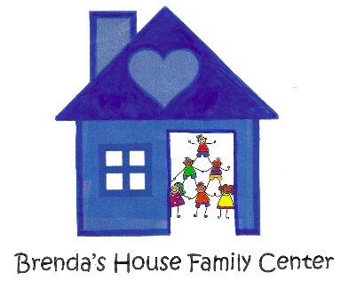
Sponsor Rules and Regulations of the Annual Seahorse Open Golf Tournament
- Fee: The fee for each sponsor is thirty dollars ($30.00) if the sponsor provides their own hole and forty dollars ($40.00) if the sponsor rents the hole from MKOTSH. Payment is due at the time that the application is completed. Checks should be made out to Mystic Krewe of the Seahorse (MKOTSH) and can be sent to 998 A Highway 90, Bay St. Louis, MS 39520.
- Donation: Proceeds from the Sponsorship Fee and Entry Fee are being donated to Brenda’s House Family Center. You may also make an additional donation to Brenda’s House Family Center and that amount will be donated directly to them as well.
- Date & Time: The Seahorse Open is on Saturday, November 9, 2019 from 4:00 pm-8:00 pm
- Location: There will be one location for Holes. Placement of your hole will be determined by the Chairman. The Pirate Central Clubhouse will be located on the corner of Beach Blvd. & Court Street. All of the holes will be located at Beach Blvd. & Court Street.
- Set up Time: 12:00 pm - 3:00 pm
- Hole: Each sponsor will build, create, and manufacture a hole in conjunction with their theme and/or business. If your business would like to rent a Hole from the Krewe please contact Al Copeland at 504-214-5113 as early as possible! If you rent a hole from the Krewe, your hole will not be specific to your business or theme but it will have your name on the Hole. If you would like to provide a sign to go with your Hole please let us know.
- Attendant: If you would like to send an attendant to man your Hole you can. Krewe members will be overseeing the location but will not be manning individual holes.
- Specials: The Mystic Krewe of the Seahorse is asking each sponsor to provide a coupon to put into the goodie bags for each adult participant. If you have any other player specials, mementos, and/or any other items to include please get those to us ahead of time. Approximately 75 bags will be made. All adult players will be given a goodie bag containing the coupons for players to later shop with those merchants sponsoring the Seahorse Open.
- Entries: Entries to the Seahorse Open will be sold the day of the event at the Pirate Central Clubhouse.

___________________________________ ___________________________
Hole Sponsor Signature & Date Krewe Representative

